STUDENT NAME: M. Subetha
YEAR: 2026
COLLEGE CODE: 131
COLLEGE NAME: Merit Arts and Science College
DEPARTMENT: Computer Science
SEMESTER: Third Year
ROLL NO: 24081311802112138
NMID: 3e4953cc7f5e870bb1e473edf46f743c@nm2026.in
TITLE: Food Delivery Sales and Customer Insights
GITHUB LINK: __________
DATE: 22.06.2026

Food Delivery Sales and Customer Insights

ABSTRACT

The Food Delivery Sales and Customer Insights project aims to analyze food delivery business data to understand sales performance, customer behaviour, and factors influencing customer satisfaction. With the rapid growth of online food delivery platforms, businesses generate large volumes of data related to orders, sales revenue, customer ratings, delivery times, and purchasing patterns. Analysing this data helps organizations improve customer experience and increase profitability.

The dataset used in this project contains information such as order values, customer ratings, delivery times, payment methods, customer demographics, and sales details. Python-based data analytics techniques were applied to clean, process, and analyze the dataset. Exploratory Data Analysis (EDA) was performed using Pandas, NumPy, Marplot, and Seaborg to identify trends and relationships among variables. Various visualizations, including bar charts, pie charts, histograms, and heat maps, were used to present findings effectively.

The analysis revealed that customer satisfaction is strongly influenced by delivery speed and order accuracy. Sales trends showed peak ordering periods and popular food categories. Customer ratings were found to have a direct impact on repeat purchases and overall business growth. The final outcome of the project provides valuable insights that can help food delivery companies optimize sales strategies, improve service quality, and enhance customer retention through data-driven decision-making.

- PROBLEM STATEMENT

Business Problem / Real-World Challenge

Food delivery companies face increasing competition and must continuously improve customer satisfaction while maximizing sales revenue. Understanding customer preferences, purchasing patterns, and delivery performance is essential for business success. However, large volumes of customer and sales data often remain underutilized.

This project addresses the challenge of identifying key factors that influence customer satisfaction and sales performance. By analyzing customer behaviour and delivery-related metrics, businesses can improve operational efficiency, enhance customer loyalty, and increase overall revenue.

2.Objectives

1.Analyze food delivery sales trends and patterns.

2.Understand customer ordering behavior.

3.Identify factors affecting customer satisfaction.

4.Evaluate delivery performance and customer ratings.

5.Generate meaningful business insights through data visualization.

6.Support data-driven decision-making in food delivery services.

3.PROJECT SCOPE

This project focuses on analyzing sales and customer-related data from a food delivery platform using Python in Google Colab. The scope includes data collection, preprocessing, exploratory data analysis, visualization, and insight generation. The project helps businesses understand customer preferences, improve service quality, and optimize sales performance.

4.TECHNOLOGIES USED

Development Environment

Google Colab

Programming Language

Python

Libraries Used and Dataset Source

Libraries

Pandas – Data manipulation and analysis

NumPy – Numerical operations

Matplotlib – Data visualization

Sea born – Statistical visualization

Dataset Source

Food Delivery Sales and Customer Insights Dataset

File Type

CSV File

5.APPLICATION FLOW

Step-by-Step Workflow

Step 1: Data Collection

Load the food delivery dataset into Google Colab.

Step 2: Data Understanding

Examine dataset structure, columns, and data types.

Step 3: Data Cleaning

Handle missing values, remove duplicates, and correct inconsistencies.

Step 4: Exploratory Data Analysis (EDA)

Analyze customer behavior, sales performance, and delivery metrics.

Step 5: Data Visualization

Create charts and graphs to identify trends and patterns.

Step 6: Insight Generation

Interpret results and derive meaningful business recommendations.

Step 7: Final Report Preparation

Document findings and conclusions.

6.KEY PYTHON DATA ANALYTICS CONCEPTS USED

1.Data Handling

Importing and loading datasets

Managing data structures

2.Data Cleaning

Handling missing values

Removing duplicate records

Formatting data

3.Exploratory Data Analysis (EDA)

Statistical analysis

Trend identification

7.Visualization

BARCHART :

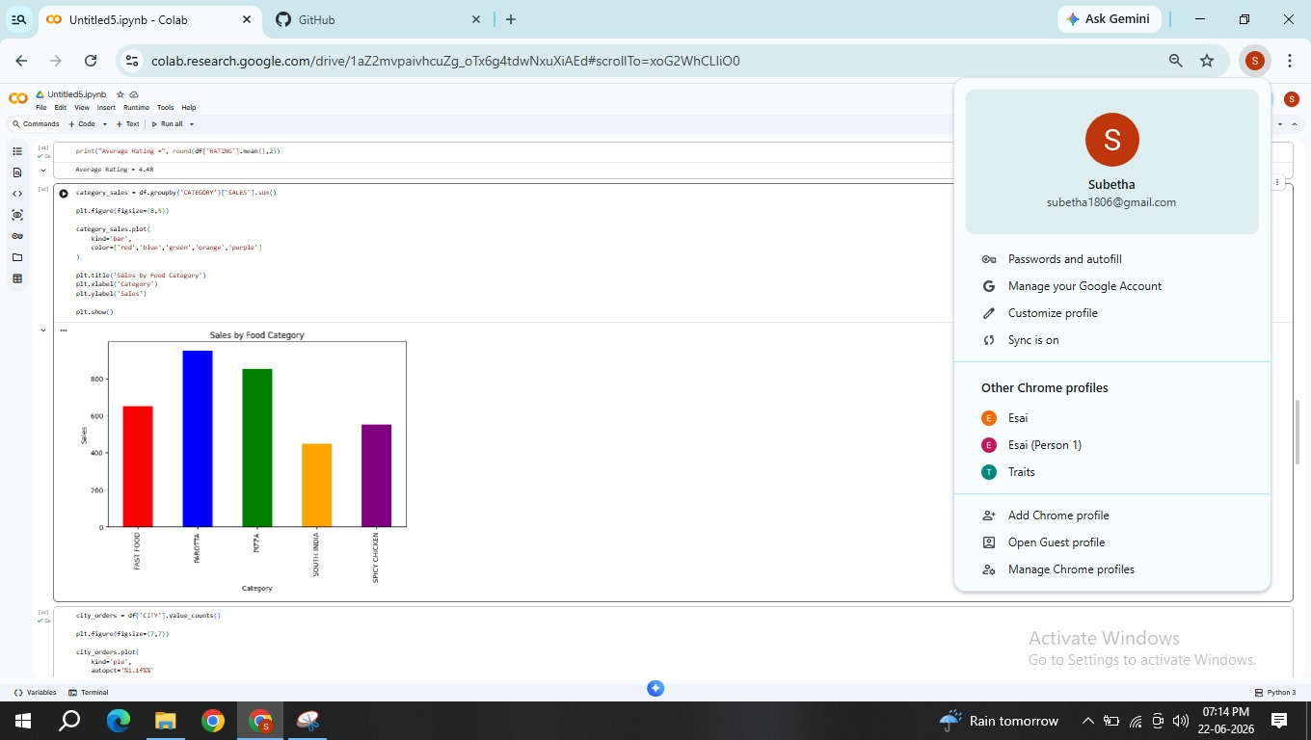

Histograms:

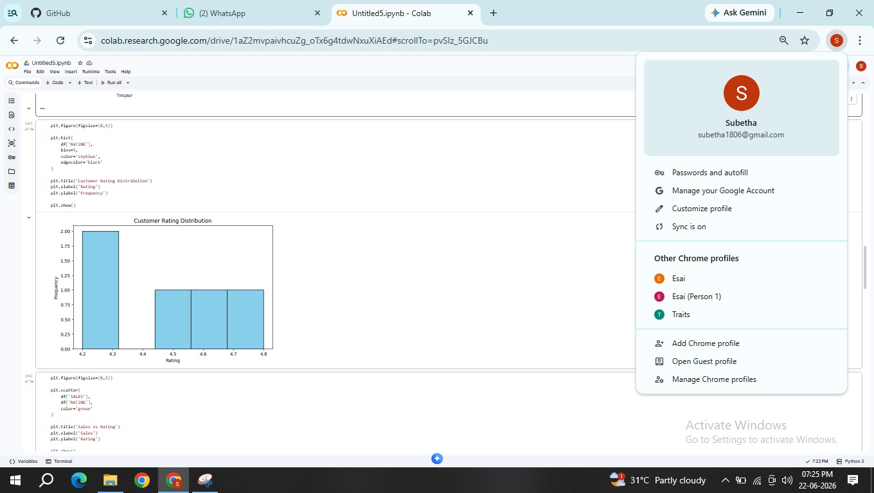

Pie Charts :

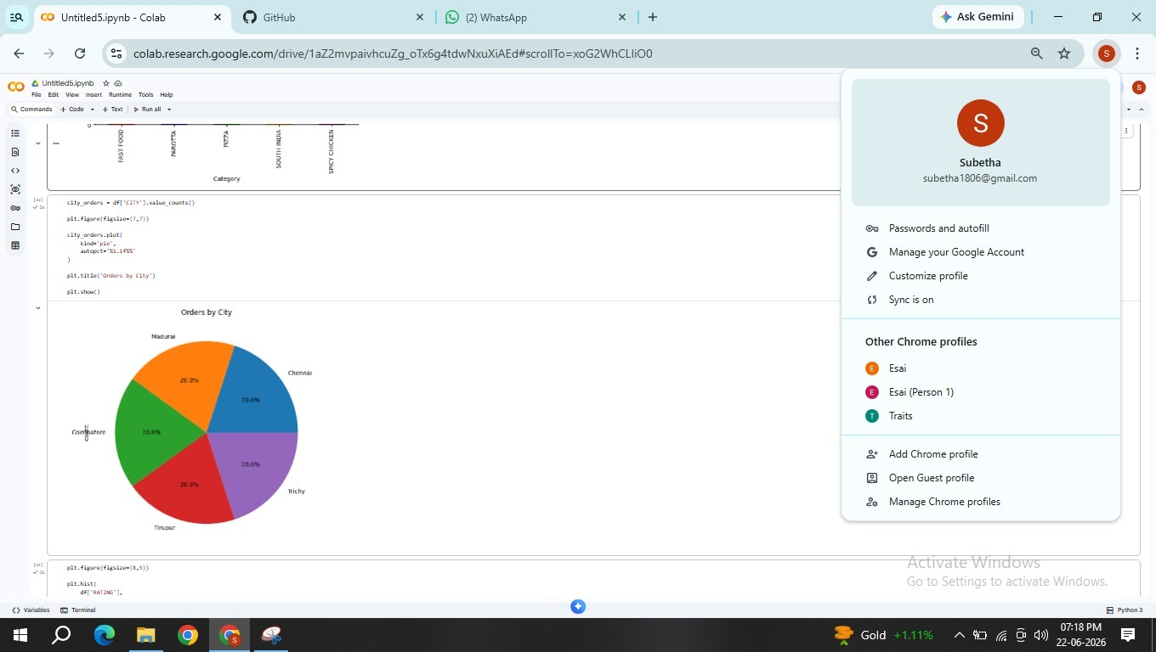

Scatter Plots :

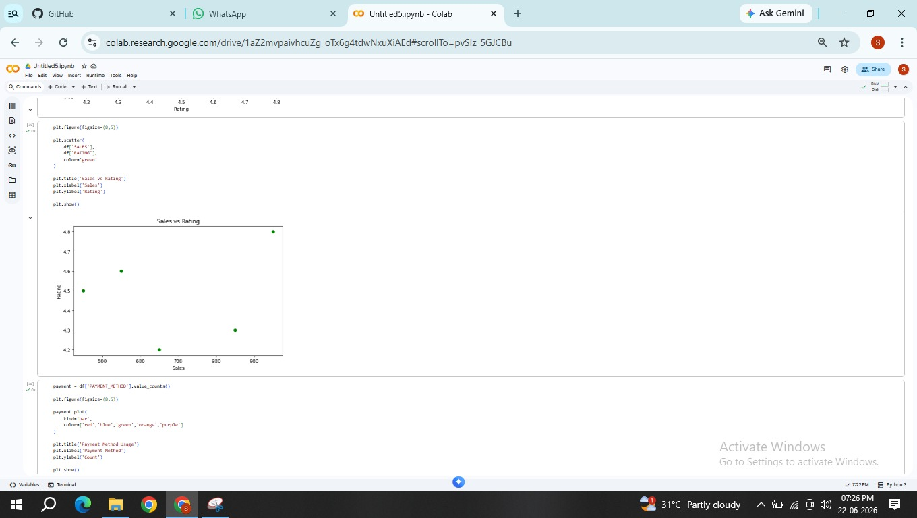

PAYMENTS METHOD USAGE :

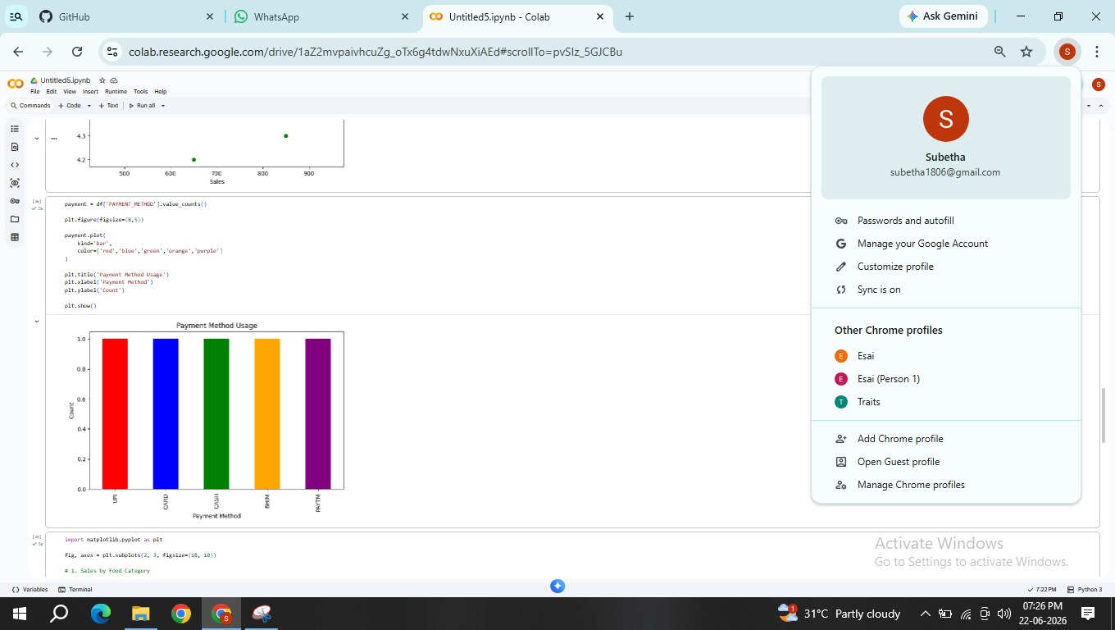

8..EXPECTED OUTPUT

Final Results

The project is expected to generate:

Cleaned and processed dataset

Customer purchasing behavior analysis

Sales performance analysis

Delivery performance evaluation

Customer satisfaction insights

Visual reports and charts

Actionable business recommendations

Insert screenshots from Google Colab showing:

Dataset preview

Cleaned dataset

Sales analysis charts

Customer rating visualizations

Final output graphs

Dashboard:
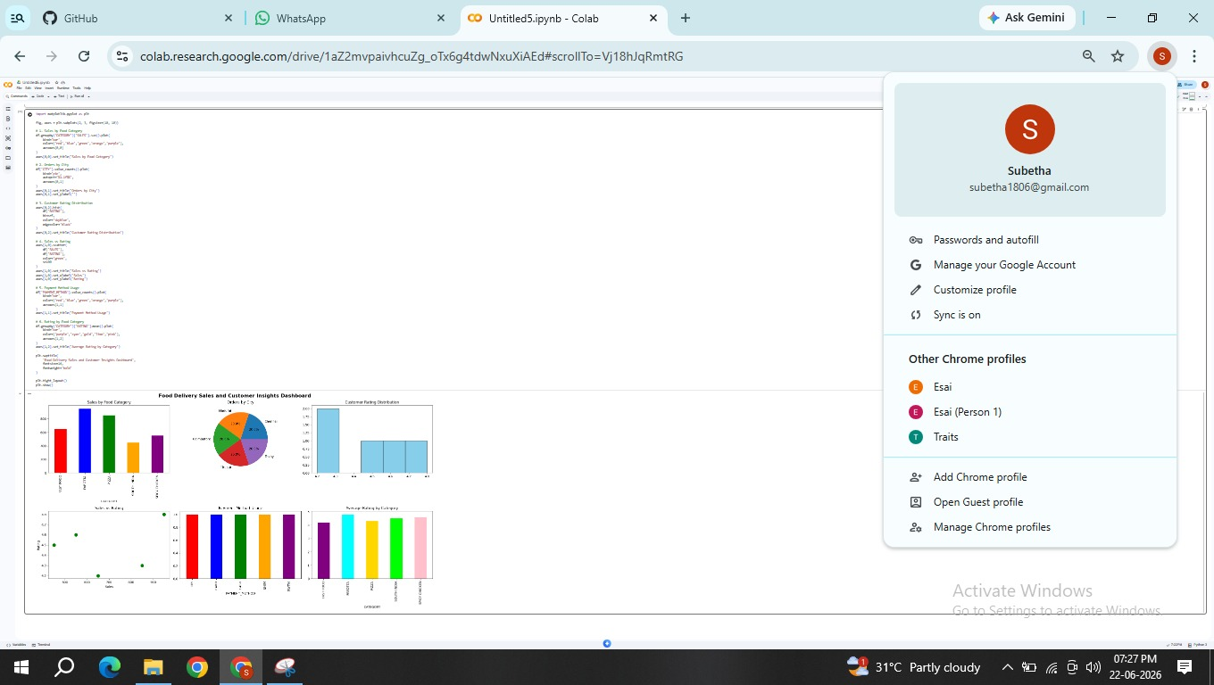

9.CHALLENGES FACED

Difficulties Encountered

- Missing values in customer and sales records.

- Inconsistent data formats.

- Presence of duplicate entries.

- Handling large datasets efficiently.

- Identifying suitable visualization methods.

Solutions Implemented

Applied data preprocessing techniques.

Standardized data formats.

Removed duplicate records.

Used optimized Python functions.

Created multiple visualizations for better understanding.

10.LEARNING OUTCOMES

Skills Gained

Technical Learning

Python programming fundamentals

Data cleaning and preprocessing

Exploratory Data Analysis (EDA)

Data visualization techniques

Business data interpretation

Practical Experience

Working with real-world datasets

Creating visual dashboards and reports

Identifying business trends

Making data-driven decisions

11.CONCLUSION

The Food Delivery Sales and Customer Insights project successfully analysed customer behavior, sales performance, and service-related factors using Python-based data analytics techniques. Through data cleaning, exploratory analysis, and visualization, significant insights were obtained regarding customer preferences, delivery efficiency, and sales trends. The results demonstrate that customer satisfaction is closely linked to delivery speed, service quality, and order accuracy. Additionally, sales patterns help businesses identify peak demand periods and popular food categories. The project highlights the importance of data analytics in improving business performance and customer experience. Overall, the insights generated can assist food delivery companies in optimizing operations, increasing customer retention, and achieving sustainable business growth.

